Blue Knob Hall Gallery & Café
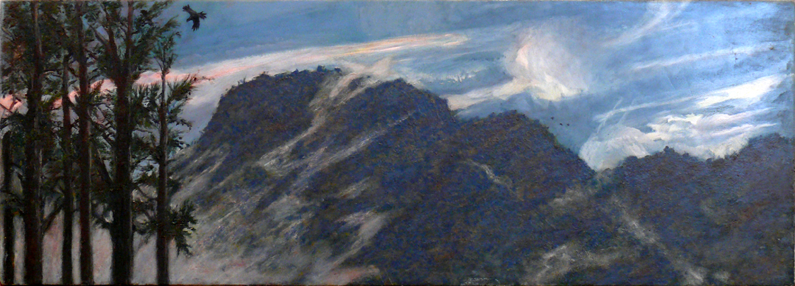
Image: Blue Knob from Gungas by Bernard Rooney
The Artist’s Choice
20th October – 4th December
Opening night Friday 21st October 6.30pm
A set meal is available at $15 per person plus $4 for dessert.
Bookings essential, phone the Gallery on 66897449

Blue Knob Hall Gallery 719 Blue Knob Road, Lillian Rock NSW 2480
Phone: (02) 66897449 email: bkhgallery@aapt.net.au www.blueknobgallery.com
Open Thursday to Sunday 10:00am - 4:00pm

