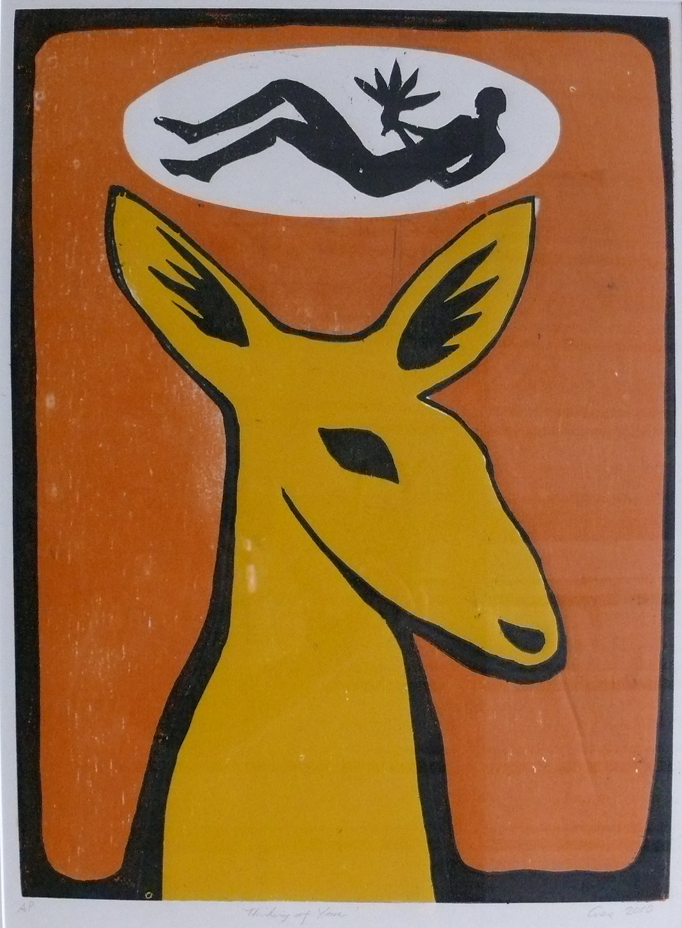
Print

Woodcut by Steve Giese
14th July - August 21st
Blue Knob Hall Gallery & Café
Opening night Friday 15th July 6.30pm
Dinner available from 7pm at $15 per person

Blue Knob Hall Gallery 719 Blue Knob Road, Lillian Rock NSW 2480
Phone: (02) 66897449 email: bkhgallery@aapt.net.au www.blueknobgallery.com
Open Thursday - Sunday 10:00am - 4:00pm

