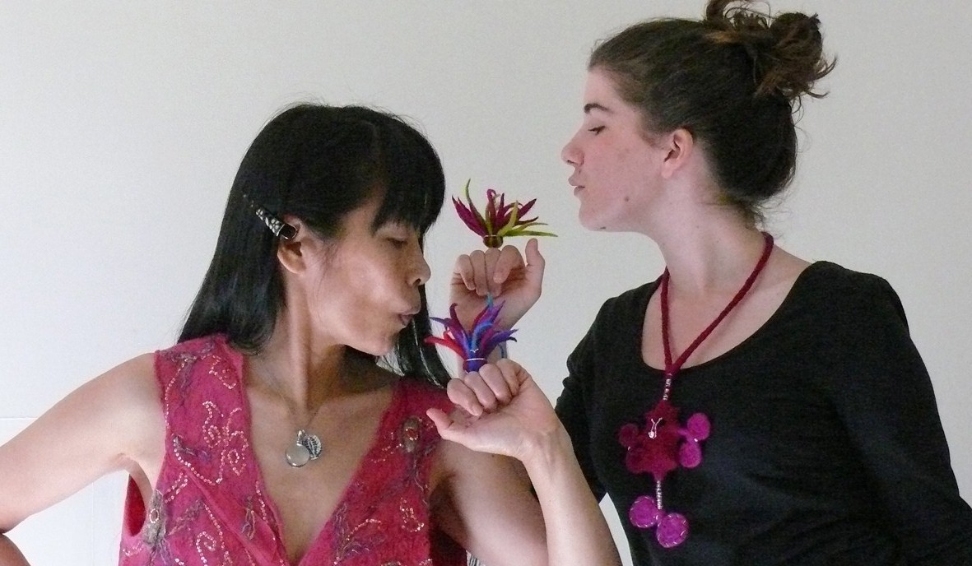
Of Fibre

Blue Knob Hall Gallery from May 15th - June 10th.
Don't miss this year's annual 'Of Fibre' Exhibition. It's our most dynamic show yet, and features the diversity of over forty fibre artists. Lots of new exhibitors have come forward to surprise and delight. It's always a treat to see how creative evolution plays out in the skilful works of local fibre artists.
Opening night Friday May 20th is going to be something special this year so mark the date. Come and view the Exhibition at 6 pm. The all Felt Fashion Show will begin at 6:30 and will showcase the extraordinary range of felt making skills in the area.
A set meal is available at the Cafe on the night for $15 per person which will include dessert. Booking for a meal is essential, phone the Gallery on 66897449.
Blue Knob Hall Gallery & Cafe, 719 Blue Knob Rd, Lillian Rock
Phone: 02 66897449 Email: bkhgallery@aapt.net.au

